National Textile University, Faisalabad


Department of Computer Science

Name | Mahnoor shahid
Class | BSCS – 5th – A
Section | 5th -A
Registration No | 23-NTU-CS-1042
Course Name | Embedded Iot systems
Submitted To | Sir Nasir Mehmod
Submission Date | 05/1/2026

Smart Classroom Project Documentation

This project implements a Smart Classroom monitoring system using an ESP32, PIR and LDR sensors, Blynk IoT platform, and a custom web dashboard. It enables real-time tracking of student presence, presentation engagement, and performance feedback in a classroom environment, helping teachers to evaluate and record student activity efficiently.

Overview

The code combines sensor data, Blynk virtual widgets, and a built-in web server to deliver a comprehensive view of classroom dynamics. It connects to WiFi, reads sensor inputs to gauge student activity and engagement, updates a mobile Blynk dashboard, and hosts a web page with analytics and feedback for each student.

Key Features
Student Activity Monitoring: Detects presence and presentation activity using PIR and LDR sensors.
Blynk Integration: Visualizes and controls session data via a mobile app.
Feedback & Analytics: Generates feedback and engagement scores per student.
Web Dashboard: Custom web page showing real-time stats, feedback, and charts.

Main Components & Architecture
ESP32
:
Executes the main logic and hosts the web server.
PIR Sensor
:
Detects motion (student presence
).
LDR Sensor
:
Detects light changes (projector state
).
Blynk IoT
:
Provides virtual widgets and mobile UI.
WebServer
:
Hosts a dashboard with a table, analytics, and Chart.js visualizations.

Project Structure

Section
Purpose
WiFi Setup
Connects ESP32 to local WiFi
Sensor Reading
Reads PIR and LDR, calculates presence and presentation
Student Management
Selects and updates current student info
Feedback Generation
Provides automated feedback based on performance
Web Dashboard
Displays real-time data and analytics
Blynk Callbacks
Handles UI interactions and data saving

Global Variables and Configuration

#define BLYNK_TEMPLATE_ID "TMPL6bnrG4pnK"
#define BLYNK_TEMPLATE_NAME "Smart ClassRoom"
#define BLYNK_AUTH_TOKEN "S6ratnohzoGe9T94WaLasaZ2I6pIge4s"

#define BLYNK_PRINT Serial

#include <WiFi.h>
#include <BlynkSimpleEsp32.h>
#include <WebServer.h>

char ssid[] = "Haru";
char pass[] = "Haruki12";

// ================== PINS ==================
const int pirPin = 34;
const int ldrPin = 35;

// ================== VIRTUAL PINS ==================
#define V_SELECT_STUD V2
#define V_ACTIVE_STUD V3
#define V_STUDENT_PIR V5
#define V_PROJECTOR V6
#define V_PRES_TIME V10
#define V_ATTENDANCE V12
#define V_SCORE V15
#define V_REMARKS V16
#define V_SAVE V17
#define V_SAVED_SCORE V18
#define V_SAVED_REMARKS V19

WebServer server(80);
BlynkTimer timer;

// ================== STUDENT DATA ==================
struct StudentData {
String name;
int presPercent; // Presentation timing %
int presencePercent; // Attendance %
int score;
String remarks;
};

StudentData students[] = {
{"Haruki", 0, 0, 0, ""},
{"Mano", 0, 0, 0, ""},
{"Ibana", 0, 0, 0, ""},
{"Amna", 0, 0, 0, ""}
};

Sensor Reading and Engagement Calculation

The system continuously reads inputs from the PIR and LDR sensors:
PIR Sensor: Detects student motion, marking them present.
LDR Sensor: Detects when the projector is ON (increased light level).
Presence Percent: Calculated by time spent detected by PIR.
Presentation Percent: Calculated by time projector is ON.

Engagement Calculation Algorithm:
int calculateEngagement(StudentData s){
int baseScore = (s.presencePercent * 0.4) + (s.presPercent * 0.6);
if(s.remarks.indexOf("participat") >= 0) baseScore += 10;
if(s.presencePercent < 50) baseScore -= 15;
if(baseScore < 0) baseScore = 0;
if(baseScore > 100) baseScore = 100;
return baseScore;
}

Weighting: 40% attendance, 60% presentation.
Bonus: +10 if remarks mention 'participation'.
Penalty: -15 if presence < 50%.
Clamped: 0–100%.
Sensor Data Update Flow
presence info
projector info
readSensors called every 1s
PIR Sensor - Motion
LDR Sensor - Projector State
Compute presence/presentation %
Update Blynk Widgets
Update Student Data

Blynk Virtual Pins
Virtual Pin
Purpose
V2
Student selection dropdown
V3
Displays current student name
V5
PIR sensor status
V6
Projector state
V10
Presentation time %
V12
Attendance %
V15
Score input
V16
Remarks input
V17
Save button
V18
Saved score display
V19
Saved remarks display

Student Selection, Scoring, and Saving
Score/Remarks: Updates student struct fields.
Save: Stores results and ends session.

Feedback Generation

Feedback is dynamically generated for each student based on their attendance, presentation, and remarks:
String generateFeedback(StudentData s) {
String feedback = "<ul class='feedback-list'>";

// Attendance feedback
if(s.presencePercent >= 15) {
feedback += "<li> Excellent class participation!</li>";
} else if(s.presencePercent >= 10) {
feedback += "<li> Good engagement, try to participate more</li>";
} else {
feedback += "<li> Needs to increase participation</li>";
}

// Presentation feedback
if(s.presPercent >= 15) {
feedback += "<li> Outstanding presentation skills</li>";
} else if(s.presPercent >= 10) {
feedback += "<li> Solid presentation delivery</li>";
} else if(s.presPercent > 0) {
feedback += "<li> Practice presentation timing</li>";
}

// Custom remarks
if(s.remarks.length() > 0) {
feedback += "<li> Teacher note: " + s.remarks + "</li>";
}

feedback += "</ul>";
return feedback;

Web Dashboard

The ESP32 hosts a web server at its local IP, accessible over LAN.

Web Page Features
Student Overview Table: Displays all students with attendance, presentation, scores, remarks, and feedback.
Color Coding: Attendance and presentation cells color-coded for quick status.
Teacher Notes: Highlights the top and lowest engaged students.
Chart.js Visualization: Bar chart compares engagement scores.
Web Dashboard Layout
requests
retrieves
generates HTML
sent to
renders
Web Client Browser
ESP32 WebServer
Student Data Array
Feedback Generator
Chart.js

Code Flow Summary

- Setup: Initializes pins, Blynk, WiFi, timers, and web server.
- Loop: Handles Blynk UI, sensor timer, and web server requests.
- Sensor Timer: Reads sensors, updates student/session data, pushes to Blynk.
- Blynk Handlers: Receive UI changes (student, score, remarks, save).
- WebServer Handler: Generates styled HTML dashboard with live data and chart.

Setup and Deployment
- Connect Sensors: Attach PIR to pin 34, LDR to pin 35.
- Configure WiFi: Update _{ssid} and _{pass} in the code.
- PlatformIO: Upload firmware to ESP32 via VSCode.
- Blynk: Use credentials and set up widgets as specified.
- Access Web Dashboard: Open http://<ESP32-IP> in browser on same network.

Conclusion

This Smart Classroom project provides an interactive, sensor-driven evaluation system for teachers, combining mobile and web dashboards for optimal accessibility. The code can be customized for different environments by adjusting student data, sensors, and UI.
ScreenShots:
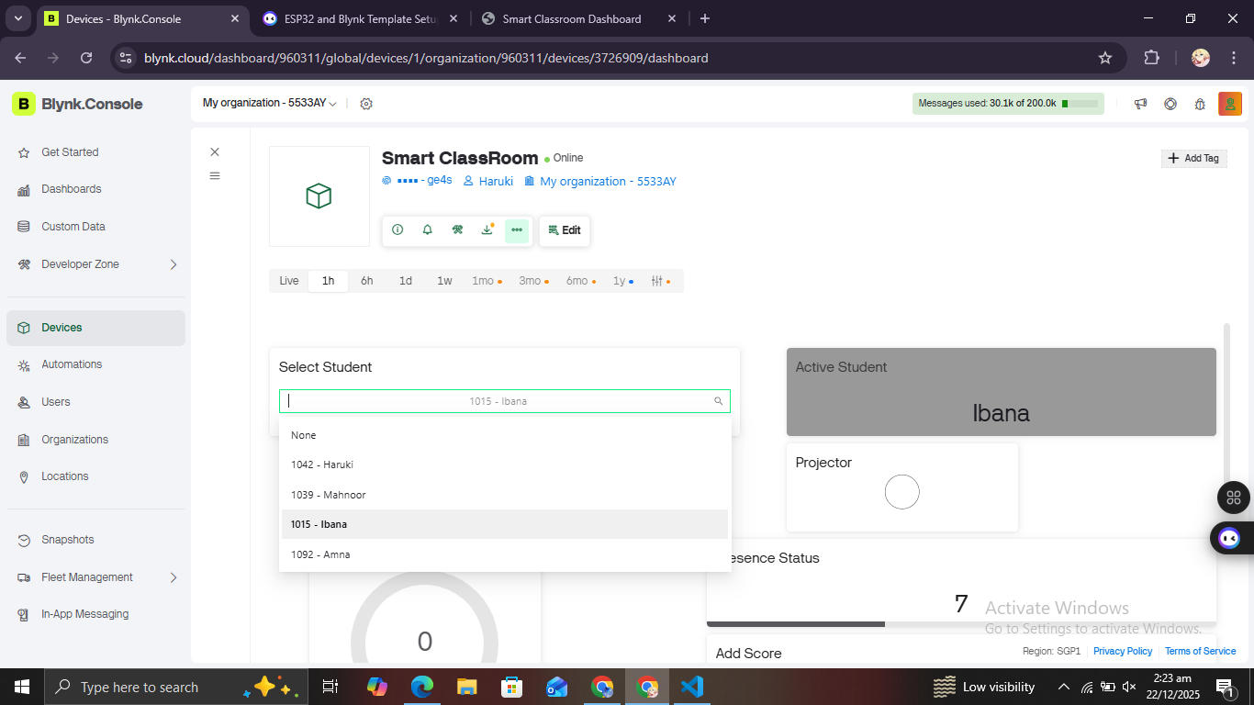
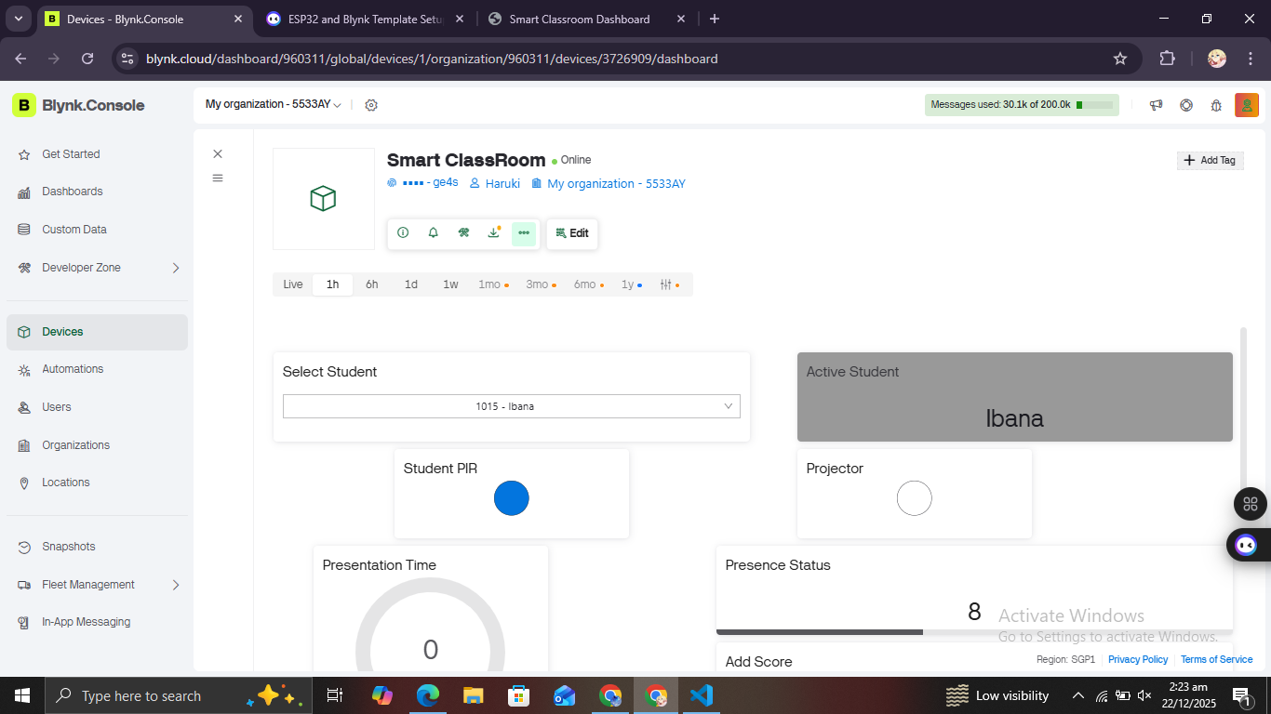
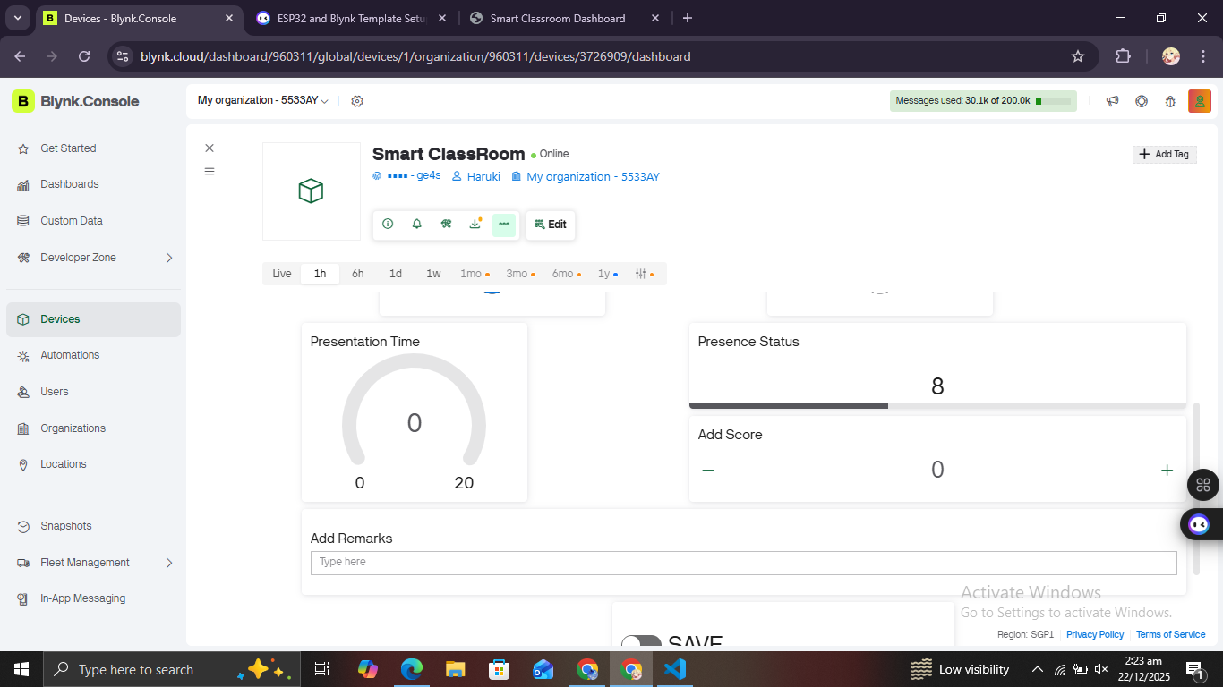
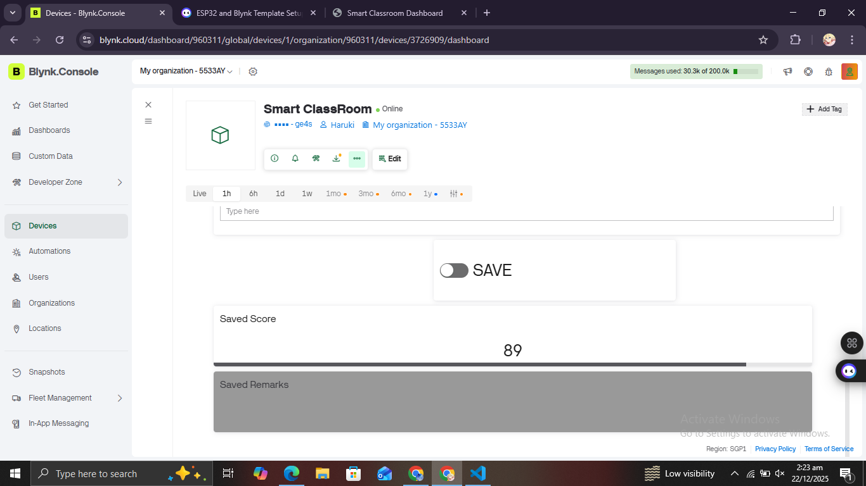
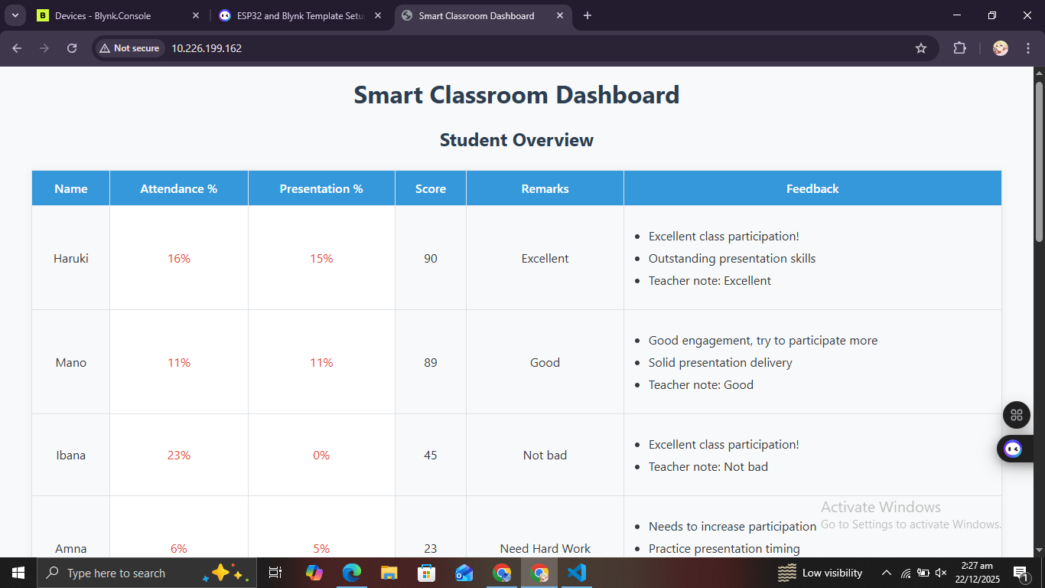
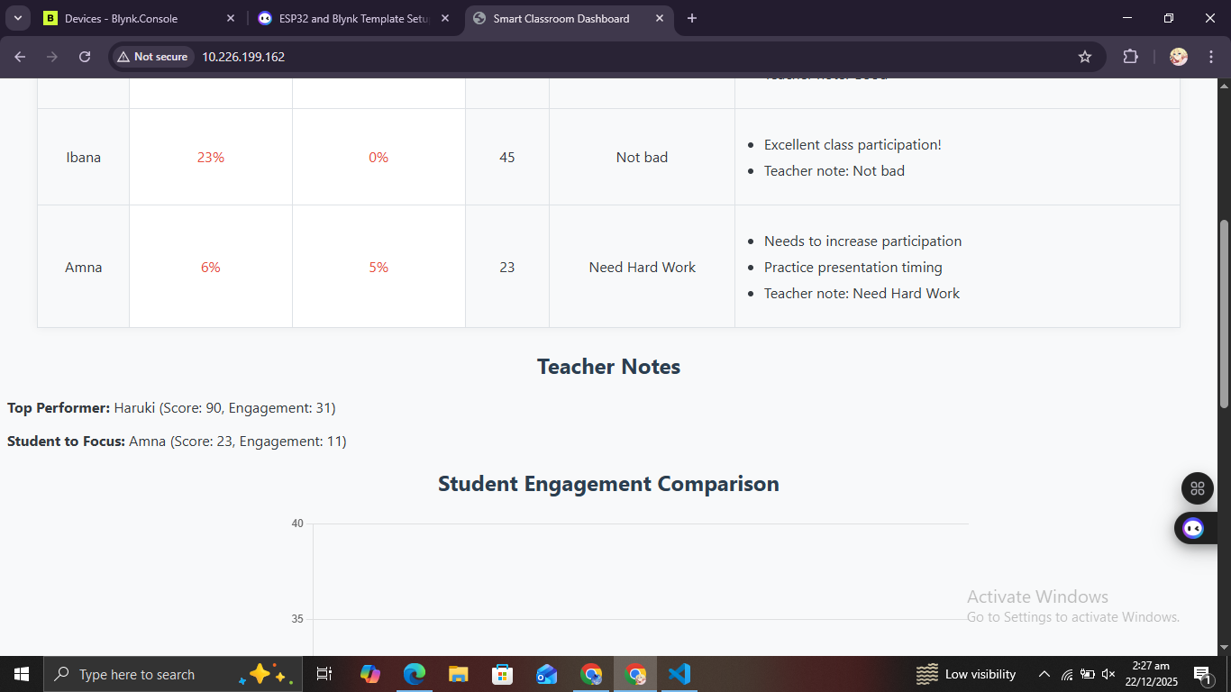
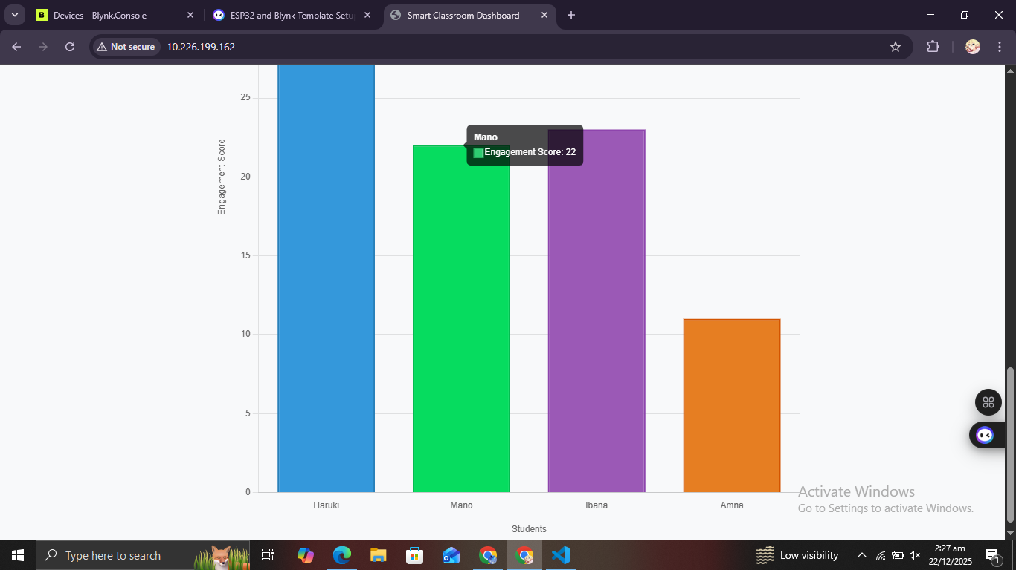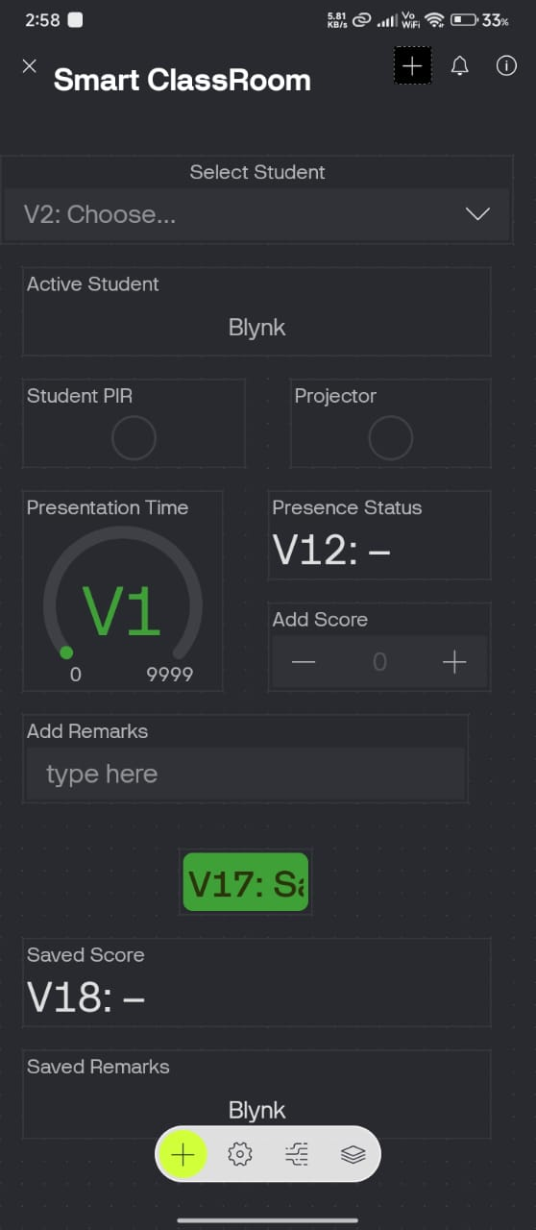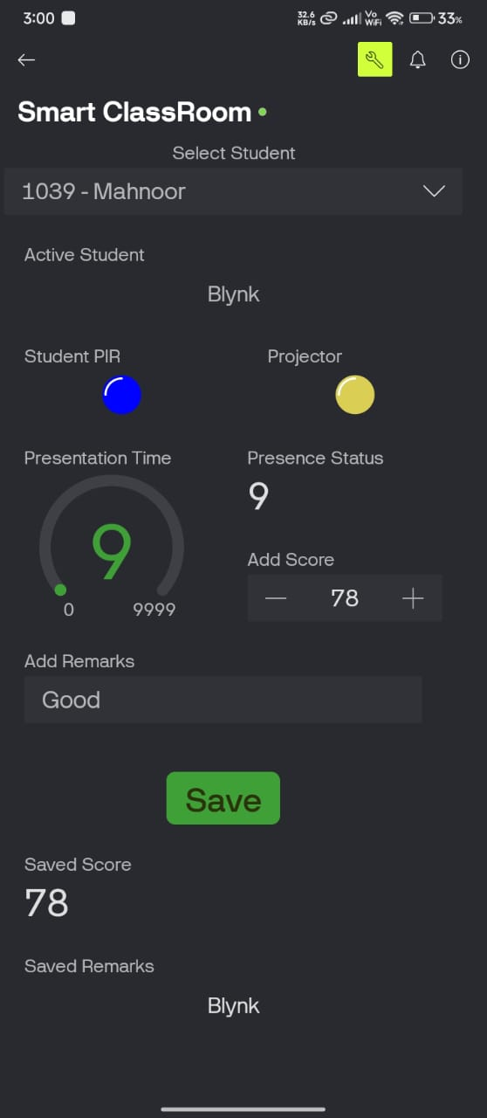

Node-RED Database Integration

Purpose
Node-RED is integrated as a database middleware to provide permanent storage of student data. It ensures attendance, presentation, scores, and remarks are saved persistently for historical analysis and reporting.

System Architecture with Node-RED
ESP32 → MQTT (Port 1883) → Node-RED → Database (MongoDB / MySQL / InfluxDB)

MQTT Configuration
Broker IP: 10.226.199.65
Port: 1883
Topic: smartclassroom/student
Protocol: MQTT v3.1.1
Client ID: ESP32_SmartClass

Data Format Sent to Node-RED
{ "student":"Student Name", "attendance":85, "presentation":92, "score":88, "remarks":"Teacher comments" }

Node-RED Flow Configuration
Node-RED subscribes to MQTT topic smartclassroom/student, parses incoming JSON data, and stores it into a database. A dashboard is used for visualization and historical queries.

Advantages of Node-RED Integration
• Permanent data storage
• Historical performance tracking
• Automated report generation
• Multi-user access
• Analytics and visualization

